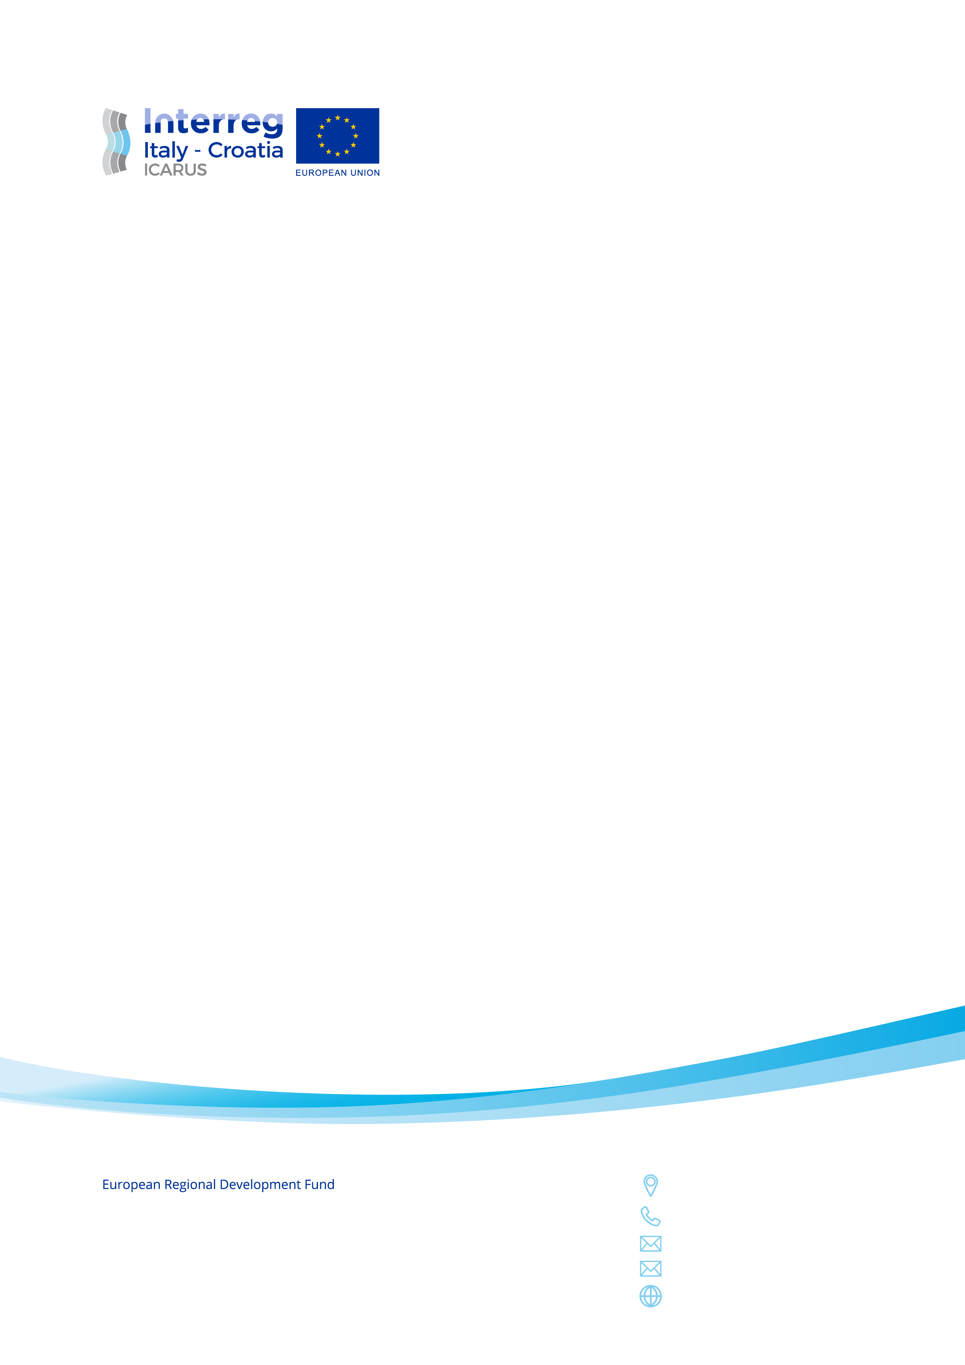

## JOIN the ICARUS’ Enlarged Transfer Programme!

With the Enlarged Transfer Programme (ETP), we want to share the experience of the ICARUS project to other organisations that are interested in cross-border and multimodal passenger connections and Mobility as a Service (MaaS).

**Applications by 3rd March 2020 at this** [**link**](https://docs.google.com/forms/d/1pelJi9W_hB8W_ayFyhrHeVevCebbUHshn8zdTm95EuI/prefill)

What’s in it for your organisation?

ICARUS will organize three training workshops, of at least two virtual, to provide training on the following topics: sharing experience of the ICARUS project, understanding innovation and mobility; ICT opportunities for public transport policy; case studies and practice of multimodal solutions for the sustainable mobility of passengers and of freight; transferability of best practices between public administrations (national and transnational). A glossary of the wider framework of SUMP approach and MaaS multifaceted implications will be delivered and illustrated.

Trainings are free of charge. Reimbursements for travel and accommodation costs are possible for the participation to the physical workshop of the training path or other events in which the ETP participants will be invited (es. site visits, final conference).

When? March 2020-April 2021

Who can join? Public Organizations empowered of decision making in the field of planning and/or implementing sustainable mobility plans (Municipalities, Regions, Ministries, Institutions & Agencies/Research Units, Civil Society Organizations).

What is the outcome of the Enlarge Transfer Programme?

Beside taking part in all the trainings, participants will be asked to draft a light action plan to improve sustainable mobility services in their area and with Italy and Croatia. The best action plan will be awarded a non-monetary prize!

What is ICARUS about?

ICARUS will test new solutions such as timetable harmonisation, car/bike sharing, ICT solutions for seamless information flow, intelligent and integrated multimodal payment systems, dynamic travel planning and cross-border intermodal services. All these actions call for behavioural changes also by the public, building on the application of new concepts, such as MaaS.

The user is the very centre of the transport services!